PAS 79:2012 Based
FIRE RISK ASSESSMENT

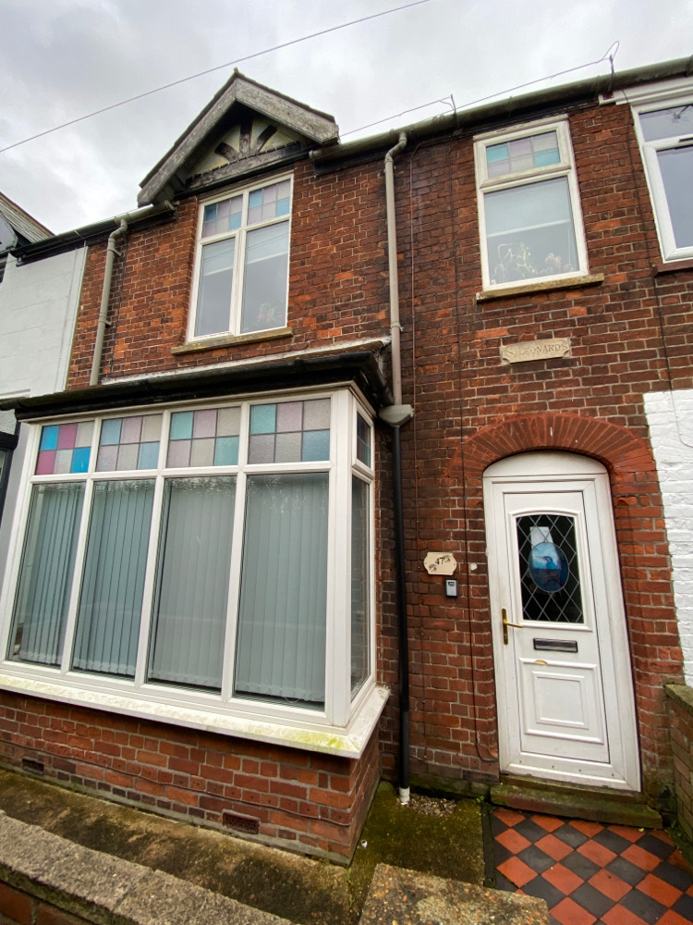

Premises Name: | HMO
Address: | 47 Queens Avenue  Kings Lynn  PE30 5LR
Prepared by: | Robert Saddington GIFireE
Date of assessment: | 19 January 2021

Current Risk Rating: | MODERATE

Table of Contents
MANAGEMENT SUMMARY 2
General Description 3
Main Significant Findings: 3
ACTION PLAN 5
CONSULTANTS RISK RATING 5
FIRE RISK ASSESSMENT 6
1. GENERAL INFORMATION 6
2. FIRE LOSS EXPERIENCE 6
3. FIRE HAZARDS AND THEIR ELIMINATION OR CONTROL 7
3.1 ELECTRICAL SOURCES OF IGNITION 7
3.2 SMOKING 8
3.3 ARSON 8
3.4 PORTABLE HEATERS AND HEATING INSTALLATIONS 9
3.5 COOKING 9
3.6 LIGHTNING 10
3.7 HOUSEKEEPING 10
3.8 HAZARDS INTRODUCED BY EXTERNAL CONTRACTORS 11
AND BUILDING WORKS 11
3.9 DANGEROUS SUBSTANCES 11
3.10 OTHER SIGNIFICANT FIRE HAZARDS THAT WARRANT CONSIDERATION, INCLUDING PROCESS HAZARDS THAT IMPACT ON FIRE PRECAUTIONS 11
4. FIRE PROTECTION MEASURES 12
4.1 MEANS OF ESCAPE 12
4.2 MEASURES TO LIMIT FIRE SPREAD AND DEVELOPMENT 13
4.3 ESCAPE LIGHTING 14
4.4 FIRE SAFETY SIGNS AND NOTICES 15
4.5 MEANS OF GIVING WARNING IN CASE OF FIRE 15
4.6 MANUAL / AUTOMATIC FIRE EXTINGUISHING APPLIANCES 16
5. MANAGEMENT OF FIRE SAFETY 16
5.1 PROCEDURES AND ARRANGEMENTS 16
5.2 TESTING AND MAINTENANCE 17
5.3 RECORDS 17

MANAGEMENT SUMMARY

General Description

Following FRA done the property been updated all throughout and fire doors replaced and adjusted.
All the works were done on recommendation form fire risk assessor and the council.

47 Queens Avenue is a former mid terraced single private dwelling which has been converted into a house of multiple occupation. The building was constructed circa 1800s, and comprises of six bedrooms, four on the first floor and two on the ground floor. The kitchen and living room are to the rear of the property, part of the kitchen, the utility room and the downstairs bathroom are a single storey extension. The building is of traditional build, rendered brick construction with timber floors, a pitched and tiled roof. A single staircase serves the protected escape route from the first floor.

The fire alarm system is a British Standard 5389:1 L2 system which was considered suitable and sufficient for a two storey bedsit HMO.

Emergency lighting is installed in the protected escape route.

Active and passive fire protection systems are aligned with the recommendations contained within Lacors.

The building must employ a simultaneous evacuation procedure which is considered most appropriate for the design and proposed use. All occupants must be instructed on the evacuation procedures upon taking residence.

Fire hydrant located at the bottom of Queens Avenue.

Main Significant Findings:

- All occupants should be instructed on the evacuation procedure upon taking residence and should confirm understanding of the procedures.
- Safe use of personal electrical equipment.
- Block type multi-plug adapter in use in bedroom two.
- Hair straighteners were found laid on the carpet in bedroom six.
- Self-closing devices have been disconnected.
- Cold smoke seals have been painted over.
- Bedroom one is fitted with a key operated lock.
- Intumescent strip and cold smoke seal missing.
- Fire alarm panel was displaying ‘fire zone 1’
- No fire routine notices are displayed within the premises
- Fire alarm system is not tested weekly.
- Emergency lighting is not tested monthly.
- Emergency lighting over-due for annual full discharge test.
- Routine fire safety records yet to be fully commenced.

Other observations are minor and should be attended when resources permit.
The traffic light system below sets out the consultant’s view of the level of risk and therefore the approximate timeframe in which the recommendations should be implemented. The table following represents the significant findings and Action Plan.

Rating | Risk | Timeframe
1.1 | Very High | Immediate.
1.2 |  | Within 1 month and mandatory.
1.3 |  | Within 3 months but temporary control measures must be adopted.
 | High but can be managed until cost effective to resolve. | This is a high cost impact across the company and requires budgetary and procurement planning. They are long term issues and can be managed.
 | Moderate | Within 6 months and mandatory.
 | Negligible | Not mandatory - when next upgrade or renovation is carried out.
 | None - recommended good practice | None.

This report and its recommendations are based on observations at the time of the audit. It cannot guarantee that a fire will not occur, and is best advice given in good faith. It also does not guarantee compliance as this is subject to the view of the regulators, however it is the view of the Consultants that the premises are unlikely to attract enforcement action if recommendations are implemented and standards are maintained. Any material change to the building, occupants or contents should be considered against this risk assessment. The risk assessments should then be reviewed to reflect the change.

ACTION PLAN

See separate document.

CONSULTANTS RISK RATING

Taking into account the nature of the building and the proposed occupants, as well as the fire protection and procedural arrangements observed at the time of this risk assessment, it is considered that the consequence for life safety in the event of a fire would be moderate.

THEREFORE AT THIS CURRENT TIME, THE RISK PRESENTED IS MODERATE

Some work is therefore required to reduce this risk, and this is detailed in the action plan.

Upon completion of the suggested improvements and provided that the fire safety procedures are followed, the residual risk will be: TOLERABLE.

Risk Level | Action and Timescale
Trivial | No action is required and no detailed records need to be kept.
Tolerable | No major additional controls required. However, there may be a need for consideration of improvements that involve minor or limited cost.
Moderate | It is essential that efforts are made to reduce the risk. Risk reduction measures should be implemented within a defined time period. This could be ongoing procedures such as staff training and is always necessary.  Where moderate risk is associated with consequences that constitute extreme harm, further assessment may be required to establish more precisely the likelihood of harm as a basis for determining the priority for improved control measures.
Substantial | The issues noted in the risk assessment when considered holistically present a risk to life should a fire occur. Physical, cultural and management issues were noted that need addressing. If the building is occupied, urgent action should be taken.
Intolerable | Building (or relevant area) should not be occupied until the risk is reduced.

FIRE RISK ASSESSMENT

Responsible Person: Darren and Lee Gould

Position: Premises owner

Persons Consulted: Ewa Chase

Consultant: Robert Saddington

Company: Prometheus Fire Safety Solutions Limited

Date of Risk Assessment: 19 January 2021

Date of Previous Assessment: N/A

Date for Review: 19 January 2022

1. GENERAL INFORMATION

1.1 The Premises – 47 Queens Avenue, Kings Lynn, PE30 5LR.
Number of Floors: 2

Age and Method of Construction: Circa 18oo’s, traditional brick construction with a pitched and slate roof.

Number of bedrooms: 6

Maximum Resident Capacity: 6

Use of Premises: House in multiple occupation.

1.2 Occupants (Maximum any one time)

Maximum number of employees at any one time: 0
Residents 6
Persons in remote areas: 0
Others: 2 (Occasional visitors)

Maximum total occupancy: 8

2. FIRE LOSS EXPERIENCE

None

3. FIRE HAZARDS AND THEIR ELIMINATION OR CONTROL

3.1 ELECTRICAL SOURCES OF IGNITION

Reasonable measures taken to prevent fires of electrical origin? YES

More specifically:

Fixed installation periodically inspected and tested? YES
(A formal inspection to afford compliance to the
IEE Wiring Regs is in place)

Portable appliance testing carried out (PAT)? YES

Suitable policy regarding the use of personal
electrical appliances? NO

Suitable limitations of trailing leads and adaptors? YES

Comments and hazards observed:
Portable appliance testing carried out 16 January 2021.

Satisfactory periodic electrical testing last carried out 14 August 2016 with no C1 or C2 faults.

Main electrical isolation cupboard in hallway.

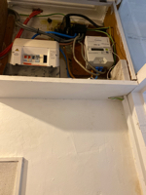

Observations/Significant Finding | Action
3.1  The introduction of personal electrical equipment within the individual bedrooms can introduce a source of ignition and a source of fuel if equipment is in a poor state of repair and or inappropriate use of extension leads is apparent. | Ensure residents understand the importance of electrical equipment being in a good state of repair and that extension leads should be as short as possible, not overloaded and that the correct plugs inserted into appropriate sockets i.e. no two pin European plugs inserted into UK sockets without an appropriate adapter.
3.1  Block type multi-plug adapter in use in bedroom two.  Block type adapters can pull away from the socket due to the wight of the plugs causing high resistance and a build-up of heat. The heat generated can be sufficient enough to ignite combustible materials. | It is recommended that multi-gang floor extension leads are used rather than block type in order to reduce the risk of fire.
3.1  Hair straighteners were found laid on the carpet in bedroom 6.  Hair straighteners generate a large amount of heat and can ignite flammable materials.  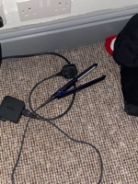 | Hair straighteners should always be placed on a heat mat during use and when cooling down after use.

3.2 SMOKING

Reasonable measures taken to prevent fires as a result
of smoking? YES

More specifically:
Is smoking prohibited in the building? YES

Is smoking prohibited in appropriate areas? YES

Are there suitable arrangements for those who wish
to smoke? YES

Comments and hazards observed:
Smoking is not permitted in the building.

Observations/Significant Finding | Action
No significant findings. | n/a.

3.3 ARSON

Does basic security against arson by outsiders appear
reasonable? YES

Is there an absence of unnecessary fire load in proximity
to the building or available for ignition by outsiders? YES

External lighting is fitted around the building and maintained? NO

The refuge bin area is remote from the building? YES

Is CCTV installed and maintained in working order? N/A

Comments and hazards observed:
Refuge containers are stored at the rear of the property.

Observations/Significant Finding | Action
No significant findings | n/a.

3.4 PORTABLE HEATERS AND HEATING INSTALLATIONS

Is the use of portable heaters avoided where practical? YES
*emergency use only.

Are portable heaters used: NO

Is the use of the more hazardous types (e.g. radiant heaters/
fan heaters) avoided? N/A

Are suitable measures taken to minimise the hazard of YES
ignition of combustible materials?

Are fixed heating installations subject to regular maintenance? YES

Comments and hazards observed:
If portable heaters are to be used, they must be the safer, low-surface temperature (LST) or oil filler radiator type. The use of freestanding fan heaters should be avoided.

One portable heater was in use in bedroom four, it was positioned away from any flammable materials.

The premises are installed with a gas fired wet heating system, new boiler fitted 25 November 2020.

Gas shut off located within meter cupboard outside rear of property.

Observations/Significant Finding | Action
No significant findings | n/a.
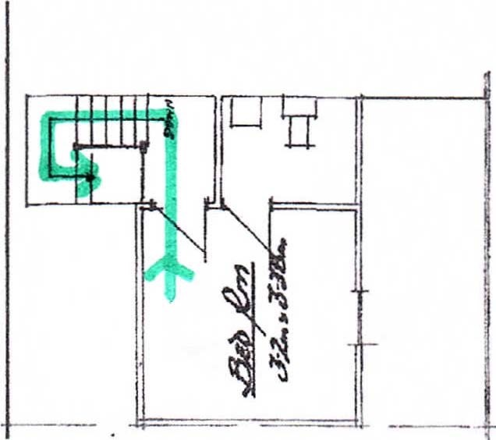
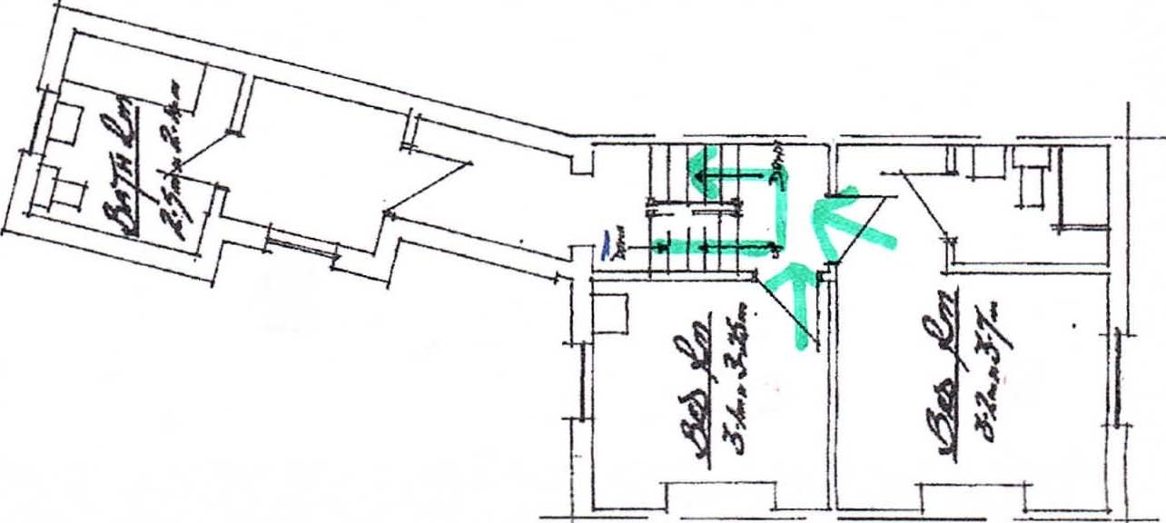
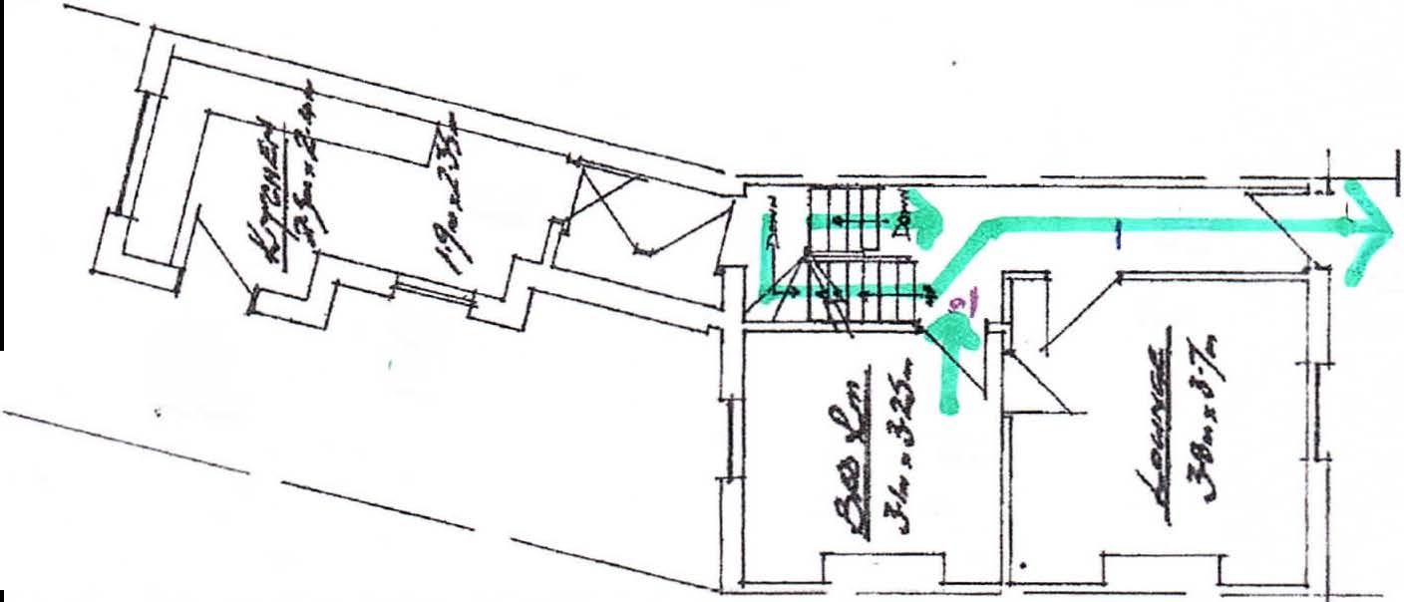
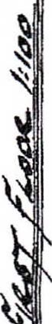
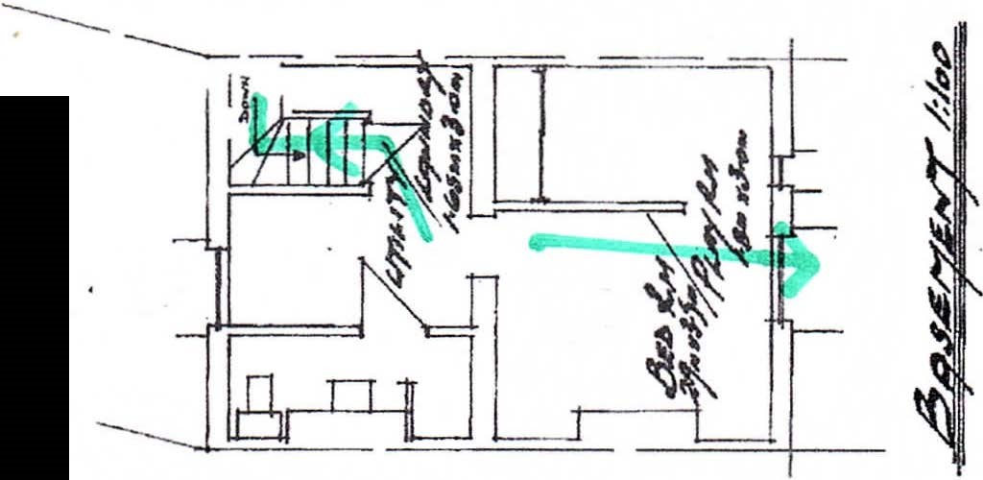
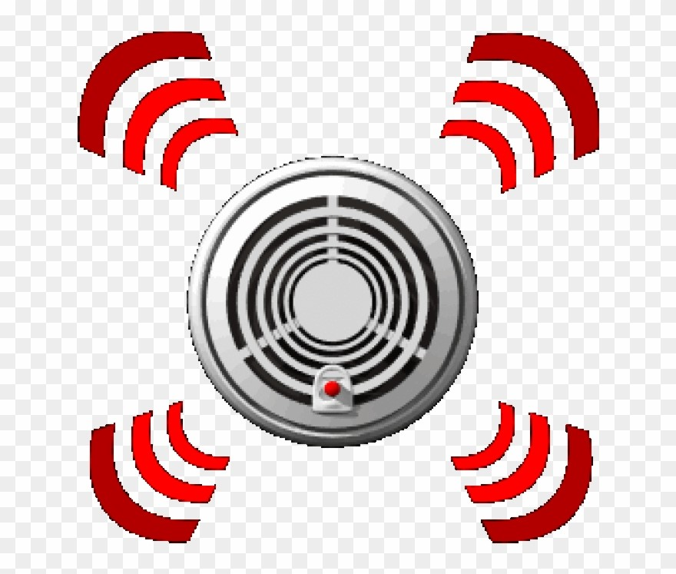
---
'
------

3.5 COOKING

Are reasonable measures taken to prevent fires as a result
of cooking? YES

More specifically:

Are suitable extinguishing appliances available? YES

Comments and hazards observed:
A fire blanket and a 2kg dry powder extinguisher is provided in the kitchen.
Observations/Significant Finding | Action
No significant findings | n/a.

3.6 LIGHTNING

Is lightning potentially a hazard? YES

Is a Lightning Protection System in place and is it maintained? N/A

Comments and hazards observed:
Lightning is not considered more of a risk above than in any other surrounding property.
Observations/Significant Finding | Action
No significant findings. | n/a.

3.7 HOUSEKEEPING

Is the standard of housekeeping adequate? YES

More specifically:
Combustible materials appear to be separate from ignition sources? YES

Avoidance of accumulation of combustible materials or waste? YES

Appropriate storage of hazardous materials? N/A

Avoidance of inappropriate storage of combustible materials? YES

Escape routes suitably free from combustible materials and ignition
sources? YES

Comments and hazards observed:
Housekeeping is good throughout the common areas.
Observations/Significant Finding | Action
No significant findings | n/a.

3.8 HAZARDS INTRODUCED BY EXTERNAL CONTRACTORS

AND BUILDING WORKS

Are fire safety conditions imposed on external contractors? YES

Is there satisfactory control over works carried out in the
building by external contractors (including “hot work” permits) YES

Comments and hazards observed:
Contractors must to be asked to present their liability insurance and should be given a brief on the fire systems and procedures prior to commencing work. Hot work permits should be required in order to ensure property protection.
Observations/Significant Finding | Action
No significant findings. | n/a.

3.9 DANGEROUS SUBSTANCES

If dangerous substances are, or could be, used, has a risk
assessment been carried out, as required by the Dangerous
Substances and Explosive Atmospheres Regulations 2002? NA

Comments and hazards observed:
No significant findings.
Observations/Significant Finding | Action
No significant findings. | n/a.

3.10 OTHER SIGNIFICANT FIRE HAZARDS THAT WARRANT CONSIDERATION, INCLUDING PROCESS HAZARDS THAT IMPACT ON FIRE PRECAUTIONS

Comments and hazards observed:
No significant findings.

Observations/Significant Finding | Action
No significant findings | n/a.

4. FIRE PROTECTION MEASURES

4.1 MEANS OF ESCAPE

Is it considered that the building is provided with reasonable
means of escape in case of fire? YES

More specifically:
Is there an adequate provision of exits? YES

Are exits easily and immediately accessible where necessary? YES

Avoidance of sliding doors as fire exits, where necessary? YES

Are there satisfactory means of securing exits? YES

Reasonable distances of travel:

Where there is a single direction of travel? YES

Where there are alternative means of escape? YES

Is there suitable protection of escape routes? YES

Are there suitable fire precautions for all inner rooms? N/A

Escape routes unobstructed? YES

Do final exits lead to place of relative safety? YES

Is a sprinkler system provided for means of escape purposes? N/A

Comments and hazards observed:
A single protected escape route provides egress from the first and ground floors. Alternative egress can be made via the kitchen to the rear of the property.
Observations/Significant Finding | Action
No significant findings | n/a.

4.2 MEASURES TO LIMIT FIRE SPREAD AND DEVELOPMENT

Is it considered that there is:

Compartmentation of a reasonable standard? YES

Are there minimal Service penetrations between compartments and are
any adequately fire-stopped? YES

Are compartment walls adequate and appropriate to protect the building
and its occupants and achieve evacuation processes? YES

Are firewalls in roof spaces appropriate and in good repair, with minimal
penetrations? YES

Are compartment ceilings imperforate? YES

Are there reasonable limitations of the linings that may promote
fire spread? YES

Are there any external linings/cladding which may promote,
or contribute to, fire spread? (if yes provide a specific commentary/
assessment below) NO

Are Fire Doors of appropriate construction, effectively self-closing NO
where required, close-fitting in their frames and fitted with
intumescent strips and cold smoke seals?

Comments and hazards observed:
All doors leading onto the escape route are 30-minute fire-resisting (with the exception of low risk bathrooms) and the walls are of sound construction.

A solid wall separates the loft space from the adjoining property.

Observations/Significant Finding | Action
4.2  Self-closing devices have been disconnected on the following doors:  Bedroom 3  Bedroom 4  Bedroom 6  Living room  Rear kitchen door  The disconnecting of self-closing devices can compromise the means of escape should a fire start in one of the risk rooms and the door is not closed.  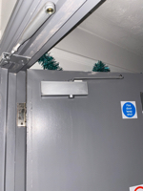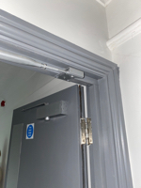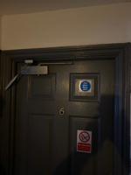  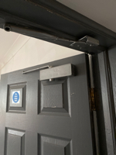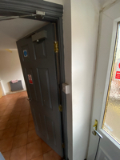 | Ensure the residents are made aware of the potential consequences of disconnecting self-closing devices.  Regular door inspections should be carried out to ensure the self-closing devices are attached.
4.2  Cold smoke seals have been painted over rendering them ineffective at preventing the passage of cold smoke from the risk room to the escape route on the following doors:  Bedroom 1.  Bedroom 2.  Bedroom 5.  Bedroom 6.  Living room. | Ensure that smoke seals which have been painted over are replaced.
4.2  Bedroom one is fitted with a key operated lock.  If premises need to be evacuated quickly there is currently the potential of the key being removed and delaying evacuation. | Provide a thumb turn mechanism to the door in order to ensure evacuation can be immediate and there is no risk of the door being locked with no key available.
4.2  Intumescent strip and cold smoke seal missing from below the latch of the rear kitchen fire door.  Intumescent strips and cold smoke seals are important to prevent the spread of fire and smoke. | Ensure the missing strip/ seal is replaced.

4.3 ESCAPE LIGHTING

Reasonable standard of emergency escape lighting
system provided? YES

Comments and hazards observed:
Emergency lighting is installed in the kitchen and escape route.
Observations/Significant Finding | Action
No significant findings. | n/a.

4.4 FIRE SAFETY SIGNS AND NOTICES

Reasonable standard of fire safety signs and notices? YES

Comments and hazards observed:
Fire doors are fitted with ‘fire door keep shut’ notices.
Observations/Significant Finding | Action
No significant findings. | n/a.

4.5 MEANS OF GIVING WARNING IN CASE OF FIRE

Is there a manually operated electrical fire alarm system
provided? YES

Is automatic fire detection provided? YES

Is the coverage of fire detection generally suitable? YES

Is the extent of automatic fire detection generally appropriate for the
occupancy and fire risk? YES

Are there systems for the remote transmission of alarm signals? NO

Comments and hazards observed:
The fire alarm system is a British Standard 5389:1 L2 system which was considered suitable and sufficient and exceeds the recommendations contained within Lacors for a two storey bedsit HMO.

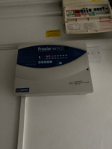
Observations/Significant Finding | Action
4.5  Fire alarm panel was displaying ‘fire zone 1’ and the LED on the hallway detector head was illuminated. | Residents should be instructed on the correct method of resetting the system following false activation.

4.6 MANUAL / AUTOMATIC FIRE EXTINGUISHING APPLIANCES

Is there suitable provision of portable fire extinguishers? NO

Are all fire extinguishing appliances readily accessible and
appropriately maintained? NO

Is there a sprinkler system provided? NO

Comments and hazards observed:
2 litre AFFF extinguisher sited on the landing, 2 kg dry powder extinguisher sited in the kitchen and a 2 litre AFFF extinguisher sited in the hall.

Observations/Significant Finding | Action
No significant findings. | n/a.

5. MANAGEMENT OF FIRE SAFETY

5.1 PROCEDURES AND ARRANGEMENTS

Fire safety is managed by: Premises owner.

Appropriate fire procedures in place? NO

More specifically:

Are procedures in the event of fire appropriate and
properly documented? NO

Are there suitable arrangements for summoning the YES
fire and rescue service?

Comments and hazards observed:
Residents to be made aware of procedures on occupation including action to be taken on the fire alarm sounding and how to call the fire service.
Observations/Significant Finding | Action
5.1  No fire routine notices are displayed within the premises.  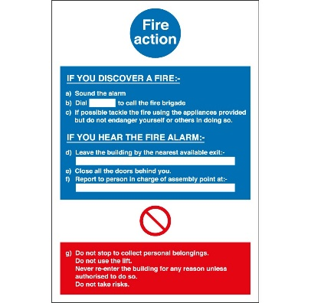 | Site fire routine notices adjacent to each manual call point within the property and ensure the residents understand what to do in the event of fire.

5.2 TESTING AND MAINTENANCE

Adequate maintenance of the premises? NO

Weekly testing and periodic servicing of fire
detection and alarm systems? NO

Monthly and annual testing routines for escape lighting? NO

Annual maintenance of fire extinguishing appliances? YES

Weekly testing and periodic inspection of sprinkler installations? N/A

Annual inspection and test of lightning protection system? N/A

Comments and hazards observed:
Safety systems must receive regular servicing and testing.
Observations/Significant Finding | Action
5.2  Fire alarm system is not tested weekly. | Ensure weekly test of the fire alarm system is carried out and recorded in the premises logbook.
5.2  Emergency lighting is not tested monthly. | Ensure monthly test of the emergency lighting is carried out and recorded in the premises  logbook.
5.2  Emergency lighting over-due for annual full discharge test; last done 08 February 2019 | Ensure emergency lighting system is serviced.

5.3 RECORDS

Appropriate records of:

Fire alarm test? NO

Escape lighting tests? NO

Comments and hazards observed:
Routine testing and inspections
Fire alarm system (weekly test) no record
Emergency lighting (monthly test) no record
Firefighting equipment (monthly check) no record
Fire doors (monthly check) no record
Portable appliance testing 16 January 2021
Stat tests
Gas new boiler installed 25 November 2020
Electricity 14 August 2016
Fire alarm system (annual service) 13 October 2020
Emergency lighting (annual service) 08 February 2019
Fire extinguishers March 2020

Observations/Significant Finding | Action
5.3  Routine fire safety records yet to be fully commenced.  Records provide vital evidence that tests and checks are being made. | Ensure all fire safety tests and checks are carried out and the results recorded.

Appendix

